


VALIDATING AWS LANDING ZONE SETUP
BEST PRACTICES GUIDANCE FOR ILLINOIS INSTITUTE OF TECHNOLOGY (IIT) BY TRIANZ
AWS Prescriptive Guidance: AWS Landing Zone Evaluation & Recommendations

TRIANZ CONFIDENTIAL trianz.com

Statement of Confidentiality
The information contained in this document is intrigued to Trianz. It shall not be disclosed, duplicated, or used for any purpose other than that stated herein, in whole or in part, without the express written consent of Trianz.

Document Control Information
Title | AWS Cross Account Backup Document
Author |  | Version: | 1.0
Reviewer |  | Approver:

Information Classification

☐ | Public
☒ | Internal
☒ | Confidential
☐ | Restricted

Table of Contents
Landing Zone Inspection Details 5
IIT AWS Architecture 5
AWS Organization 6
Current Account Structure 6
Observation: AWS Organizations Summary 6
AWS Landing Zone - Service Review & Recommendation 7
Currently Enabled Services 7
Currently Disabled Services – Action Needed 8
AWS Organisational Policies 8
Enabled Policies in AWS Organization (Current Status) 8
Disabled Policies (Action Needed) 8
AWS Service Control Policies (SCP) - Analysis and Recommendations 9
Existing SCP Policies – Overview from Screenshot 9
Tag Policies - Analysis and Recommendations 10
Tag Policies 10
AWS Landing Zone Guardrails - As per Well-Architected Framework 11
Guardrail Overview (Current Control Summary) 11
Enabled Controls (Preventive & Detective) 11
Guardrails Recommendation 14
IAM 15
Account Factory 15
Account-wise Network Mapping 15
VPC, Subnets, and Routing 15
Transit Gateway Attachment 16
Network Hub Account 16
Shared Service Account 23
Load Balancer 24
S3 Endpoints 25
Cloud Watch 26
Production Account 26
S3 Endpoints 26
Production_DR Account 27
S3 Endpoints 29
Development Account 30
S3 Endpoints 31
Test Account 31
S3 Endpoints 32
Log Archive account 33
Audit account 33

Landing Zone Inspection Details

IIT AWS Architecture
This High-Level Design (HLD) illustrates the current IIT AWS environment (Figure: 1),
Most of the infrastructure operates in the US-EAST-x (xxxx) Availability Zone, with global services (e.g., IAM, Route 53) running in US-EAST-x region,
Below showcasing the following key aspects of the AWS Landing Zone architecture:
- Organizational account structure (Management, Internet/Inspection (Network) , Distribution Account, Centralized Log Account Audit Account and Research Account
- Placement of key AWS services within each account
- Network connectivity across accounts (e.g. Transit Gateway, VPN, RAM, etc.)
- Environment segmentation (Dev, Test, Prod, etc.,)
- Security controls and guardrails (SCPs, AWS Config, CloudTrail, etc.)
- Centralized logging and monitoring

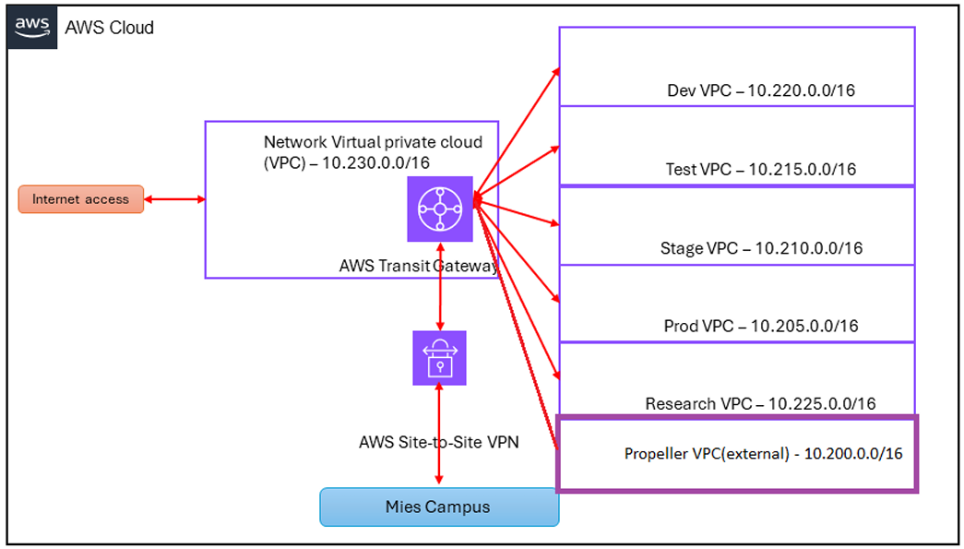
Figure: 1

AWS Organization

Current Account Structure

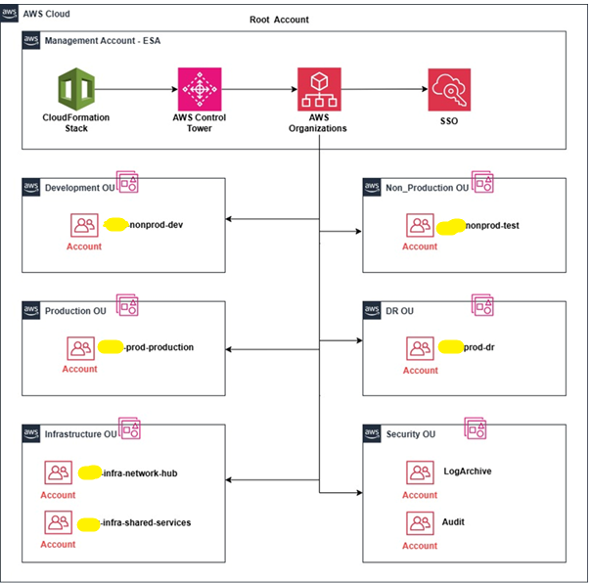

Figure: 2

Observation: AWS Organizations Summary
Using the management account, the Organizational Units (OUs) and associated AWS accounts listed above were created for workload, infrastructure, and security separation.
- Total Organizational Units (OUs): 6
- Total Accounts: 6

OU's (Under Root) | Account
Development OU
Non_Production OU
Production OU
DR OU
Infrastructure OU
Security OU | LogArchive Account
Security OU | Audit Account

AWS Landing Zone - Service Review & Recommendation

Currently Enabled Services

IIT help is required to gather the information about the current services.
AWS Organization Services (Enabled)
- Security Hub Centralizes and consolidates security findings across AWS accounts.
- VPC Reachability Analyzer Helps troubleshoot network connectivity issues between VPC resources.
- Resource Access Manager (RAM) Allows sharing of resources like subnets and TGWs across accounts.
- IAM Access Analyzer Identifies resources shared with external entities or unintended access.
- AWS Config Tracks AWS resource configurations and compliance over time.
- CloudTrail Records all API and user activity for auditing and governance.
- CloudFormation StackSets Deploys CloudFormation templates across multiple AWS accounts/OUs.
- AWS Network Manager Visualizes and manages global network topologies in AWS.
- SSO (IAM Identity Center) Provides centralized access control for users across AWS accounts.
- Control Tower Automates landing zone setup with best practices and account governance.
- Audit Manager Automates evidence collection to simplify audits and compliance.
- MGN (AWS Application Migration Service) Migrates servers from on-prem to AWS.
- Amazon GuardDuty Continuously monitors and detects threats in your AWS environment.
- Amazon Macie Uses machine learning to discover and protect sensitive data in S3.

Currently Disabled Services – Action Needed
IIT help is required to gather the information about the current services.

AWS Organization Services (Disabled)
Service | Recommendation | Use Case
Systems Manager | Must enable | For patching, automation, and remote management.
AWS Backup | Must enable | For centralized backup and disaster recovery.
Amazon Inspector | Highly recommended | For vulnerability scanning of EC2, Lambda, and containers.
Firewall Manager | Highly recommended | For centralized firewall and WAF policy management.
Trusted Advisor | Recommended | For cost optimization, security, and performance insights.
Compute Optimizer | Recommended | For resource right-sizing and performance tuning.
Service Catalog | Optional | Useful for standardizing approved products and templates.
AWS Identity and Access Management | Highly recommended | Foundational service for secure access control.
Service Quotas | Highly recommended | To track and manage AWS limits and avoid disruptions.

AWS Organisational Policies

Enabled Policies in AWS Organization (Current Status)
IIT help is required to gather the information about the current services.

- Service Control Policies (SCPs) Provides guardrails and controls over AWS account permissions. Mandatory for Landing Zone governance.

- Tag Policies Helps troubleshoot network connectivity issues between VPC resources.

Disabled Policies (Action Needed)
IIT help is required to gather the information about the current services.

Disabled Policies in AWS Organization
Policy | Current Status | Recommendation | Reason
Backup Policies | Enabled/Disabled | Must Enable | Useful for applying automated, organization-wide backup plans. Enhances data protection and recovery posture.
Chat Application Policies |  | Optional | It is only needed if Amazon Q Developer access is required via Slack or Microsoft Teams.
Security Hub policies |  | Recommended | Enables automated security checks and integrations across accounts.
Resource Control Policies (RCPs) |  | Advanced (Recommended for strict environments) | Allow centralized permission control at resource level. Recommended for secure enterprise setups.

AWS Service Control Policies (SCP) - Analysis and Recommendations

Existing SCP Policies – Overview from Screenshot
IIT help is required to gather the information about the current services.

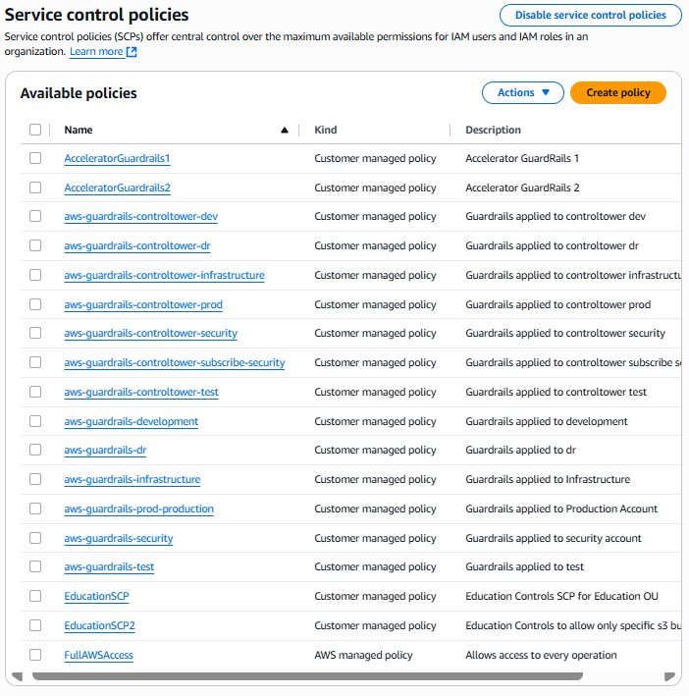
Observation –
IIT help is required to gather the information about the current services.

Recommendations:
Trianz will add these details based on observations.
<<Screenshot required.>>

Tag Policies - Analysis and Recommendations

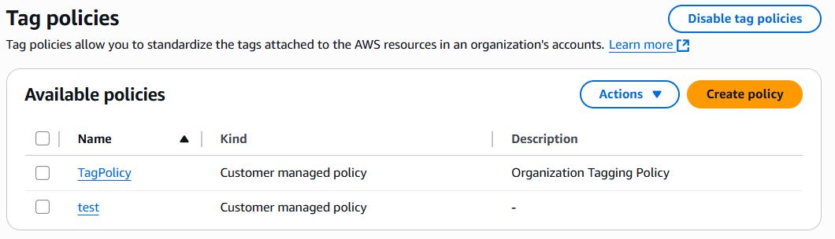

Tag Policies

Tag Policy
To enforce consistent tagging (like Environment = DEV/PRD/TST) across AWS accounts for better cost tracking, governance, and compliance.
- Observation
- IIT help is required to gather the information about the current services.
- Recommendation
Trianz will add the details based on observations.

Test Policy
- Observation
- IIT help is required to gather the information about the current services.
- Recommendation
- Trianz will add the details based on observations.

AWS Control Tower
Observation
IIT help is required to gather the information about the current services.
Why is this a Problem?
Trianz will add the details based on observations.
Recommended Fix
Trianz will add the details based on observations.

AWS Landing Zone Guardrails - As per Well-Architected Framework

Guardrail Overview (Current Control Summary)
IIT help is required to gather the information about the current services.

We have observed that 25 Preventive and 3 Detective Guardrails are currently enabled in the environment.
- Preventive controls 21
- Detective controls 3
- Proactive controls 0

Enabled Controls (Preventive & Detective)
Name | Target OUs | Behaviour | Description
[AWS-] Disallow changes to Amazon SNS subscriptions set up by AWS Control Tower | 6 | Preventive | Prevent changes to Amazon SNS subscriptions set up by AWS Control Tower to trigger notifications for AWS Config Rule compliance changes.
[AWS-GR_CLOUDTRAIL_CLOUDWATCH_LOGS_ENABLED] Integrate CloudTrail events with CloudWatch Logs | 6 | Preventive | Perform real-time analysis of activity data by sending AWS CloudTrail events to AWS CloudWatch logs.
[AWS-GR_REGION_DENY] Deny access to AWS based on the requested AWS Region for the landing zone | 6 | Preventive | Disallows access to unlisted operations in global and regional services outside of the specified Regions for the landing zone.
[AWS-GR_CONFIG_RULE_CHANGE_PROHIBITED] Disallow changes to AWS Config Rules set up by AWS Control Tower | 6 | Preventive | Prevent changes to AWS Config Rules set up by AWS Control Tower.
[AWS-GR_CONFIG_AGGREGATION_AUTHORIZATION_POLICY] Disallow deletion of AWS Config Aggregation Authorizations created by AWS Control Tower | 6 | Preventive | Prevent deletion of AWS Config aggregation authorizations created by AWS Control Tower.
[AWS-GR_AUDIT_BUCKET_PUBLIC_READ_PROHIBITED] Detect public read access setting for log archive | 1 | Detective | Detect public read access setting for Amazon S3 buckets created by AWS Control Tower in the log archive account.
[AWS-GR_CONFIG_ENABLED] Enable AWS Config in all available regions | 6 | Preventive | Identify configuration changes to AWS resources using AWS Config.
[AWS-GR_LAMBDA_CHANGE_PROHIBITED] Disallow changes to AWS Lambda functions set up by AWS Control Tower | 6 | Preventive | Prevent changes to AWS Lambda functions set up by AWS Control Tower.
[AWS-GR_IAM_ROLE_CHANGE_PROHIBITED] Disallow changes to AWS IAM roles set up by AWS Control Tower and AWS CloudFormation | 6 | Preventive | Prevent changes to AWS IAM roles set up for your accounts by AWS Control Tower and AWS CloudFormation.
[AWS-GR_CLOUDTRAIL_VALIDATION_ENABLED] Enable integrity validation for CloudTrail log file | 6 | Preventive | Protect the integrity of account activity logs using AWS CloudTrail log file validation, which creates a digitally signed digest file that contains a hash of each log that CloudTrail writes to Amazon S3.
[AWS-GR_SNS_CHANGE_PROHIBITED] Disallow changes to Amazon SNS set up by AWS Control Tower | 6 | Preventive | Prevent changes to Amazon SNS notification settings set up by AWS Control Tower.
[AWS-GR_CONFIG_CHANGE_PROHIBITED] Disallow configuration changes to AWS Config | 6 | Preventive | Record resource configurations in a consistent manner by ensuring that AWS Config settings don't change.
[AWS-GR_AUDIT_BUCKET_DELETION_PROHIBITED] Disallow deletion of log archive | 1 | Preventive | Prevent deletion of Amazon S3 buckets created by AWS Control Tower in the log archive account.
[AWS-GR_CLOUDTRAIL_ENABLED] Enable CloudTrail in all available regions | 6 | Preventive | Track AWS API call activity within your accounts using AWS CloudTrail, which records call history including the identity of the caller and the time of the call.
[AWS-GR_CLOUDTRAIL_CHANGE_PROHIBITED] Disallow configuration changes to CloudTrail | 6 | Preventive | Log API activity in a consistent manner by ensuring that your AWS CloudTrail settings do not change.
[AWS-GR_DETECT_CLOUDTRAIL_ENABLED_ON_SHARED_ACCOUNTS] Detect whether a shared account in the Security organizational unit has AWS CloudTrail or CloudTrail Lake enabled. | 1 | Detective | Detects whether a shared account in the Security organizational unit has AWS CloudTrail or CloudTrail Lake enabled. The rule is NON_COMPLIANT if either CloudTrail or CloudTrail Lake is not enabled in an account.
[AWS-GR_CT_AUDIT_BUCKET_POLICY_CHANGES_PROHIBITED] Disallow Changes to Bucket Policy for AWS Control Tower Created S3 Buckets in Log Archive | 1 | Preventive | Protect the integrity of your log archive by ensuring that no bucket policy changes occur to the S3 buckets created by AWS Control Tower.
[AWS-GR_CLOUDWATCH_EVENTS_CHANGE_PROHIBITED] Disallow changes to Amazon CloudWatch set up by AWS Control Tower | 6 | Preventive | Prevent changes to Amazon CloudWatch configuration set up by AWS Control Tower to monitor your environment.
[AWS-GR_CONFIG_AGGREGATION_CHANGE_PROHIBITED] Disallow changes to AWS Config aggregation set up by Control Tower | 6 | Preventive | Protect the integrity of AWS Config aggregation set up by Control Tower to collect configuration and compliance data.
[AWS-GR_CT_AUDIT_BUCKET_LIFECYCLE_CONFIGURATION_CHANGES_PROHIBITED] Disallow changes to lifecycle configuration for AWS Control Tower created Amazon S3 buckets in log archive | 1 | Preventive | Prevent lifecycle configuration changes to Amazon S3 buckets created by AWS Control Tower.
[AWS-GR_CT_AUDIT_BUCKET_ENCRYPTION_CHANGES_PROHIBITED] Disallow Changes to Encryption Configuration for AWS Control Tower Created S3 Buckets in Log Archive | 1 | Preventive | Prevent encryption configuration changes to Amazon S3 buckets created by AWS Control Tower.
[AWS-GR_CT_AUDIT_BUCKET_LOGGING_CONFIGURATION_CHANGES_PROHIBITED] Disallow changes to logging configuration for AWS Control Tower created Amazon S3 buckets in log archive | 1 | Preventive | Prevent logging configuration changes to the Amazon S3 buckets created by AWS Control Tower.
[AWS-GR_AUDIT_BUCKET_PUBLIC_WRITE_PROHIBITED] Detect public write access setting for log archive | 1 | Detective | Detect public write access setting for Amazon S3 buckets created by AWS Control Tower in the log archive account.

Guardrails Recommendation
To support the successful setup of the AWS Landing Zone and ensure compliance with security and governance standards, it is recommended to enable an additional 22 Guardrails. The list of these required Guardrails is provided below.
Service | Guardrail Name / ID | Implementation | Type | Category
Amazon EC2 | [CT.EC2.PV.11] Disallow public sharing of AMIs | Declarative policy for EC2 | Preventive | Security
Amazon EC2 | [CT.EC2.PV.7] Disallow public sharing of EBS snapshots | Declarative policy for EC2 | Preventive | Security
Amazon EC2 | [CT.EC2.PV.2] Require EBS encryption at rest | Service Control Policy (SCP) | Preventive | Security
Amazon S3 | [CT.S3.PV.6] Require SSE-KMS encryption for S3 uploads | Resource Control Policy (RCP) | Preventive | Security
AWS Backup | [CT.BACKUP.PV.1] Disallow tag modification on AWS Backup resources | Service Control Policy (SCP) | Preventive | Security
IAM | [AWS-GR_RESTRICT_ROOT_USER_ACCESS_KEYS] | Service Control Policy (SCP) | Preventive | Security
IAM | [AWS-GR_RESTRICT_ROOT_USER] | Service Control Policy (SCP) | Preventive | Security
Amazon S3 | [SH.S3.1] S3 Block Public Access should be enabled | AWS Security Hub | Detective | Security
Amazon EC2 | [SH.EC2.17] EC2 should not use multiple ENIs | AWS Security Hub | Detective | Networking
Amazon EC2 | [SH.EC2.19] Security groups should not allow high-risk open ports | AWS Security Hub | Detective | Security
Amazon EC2 | [SH.EC2.3] EBS volumes should be encrypted | AWS Security Hub | Detective | Security
Amazon EC2 | [SH.EC2.6] Enable VPC Flow Logs | AWS Security Hub | Detective | Operational Excellence
Amazon EC2 | [SH.EC2.7] EBS default encryption should be enabled | AWS Security Hub | Detective | Security
AWS GuardDuty | Enable GuardDuty in all accounts | Service Configuration | Detective | Security
AWS Organizations | Auto-enable Security Hub in all accounts | Service Configuration | Detective | Security
IAM | Disallow creation of IAM users (SSO only) | Service Control Policy (SCP) | Preventive | Security
AWS Organizations | Enforce Tag Policy: Owner, Environment, CostCenter | Tag Policy | Preventive | Cost Optimization
AWS Organizations | Disallow resource creation without required tags | Service Control Policy (SCP) | Preventive | Cost Optimization
AWS Budgets | Enable Budget Alerts at OU/Account level | Service Configuration | Detective | Cost Optimization
AWS Organizations | Disallow use of unapproved AWS regions | Service Control Policy (SCP) | Preventive | Reliability
AWS Backup | Enforce backup plans and policies | Service Configuration | Preventive | Reliability
AWS Backup | Disallow deletion of backup plans/vaults | Service Control Policy (SCP) | Preventive | Reliability

AWS IAM Identity Center
IIT help is required to gather the information about the current services.
<<Screenshot also required >>

Observation
- Identity Source:
  - IIT help is required to gather the information about the current services.

2. Multi-Factor Authentication (MFA) Behaviour:
IIT help is required to gather the information about the current services.
3. Delegated Administrator
Audit account (ID: 1234567890) is registered as Delegated Admin for IAM Identity Center(IIT help is required to gather the information about the current services.)

Recommendation
1. Strengthen MFA Enforcement
Trianz will update this section.
2. Correct Delegated Administrator Configuration
Trianz will update this section.

Account-wise Network Mapping

VPC, Subnets, and Routing

IIT help is required to gather the information

This table outlines the VPC and subnet configuration across core and workload accounts in the AWS Landing Zone. It includes IP ranges, private/public subnets, and associated route tables for each account.
Account Name | VPC | IP Range | Private Subnet | Public Subnet | Private Route Table | Public Route Table
IIT-NONPROD-TEST
IIT-NONPROD-DEV
IIT-PROD-PRODUCTION
IIT-PROD-DR
IIT-INFRA-SHARED-SERVICE-PROD
IIT-INFRA-NETWORK-HUB
LOG ARCHIVE
AUDIT

Transit Gateway Attachment
IIT help is required to gather the information

TGW Attachment
tgw-rt-nonprod | tgw-rt-production | tgw-rt-prod-dr | tgw-rt-network-hub | tgw-rt-shared-services

Network Hub Account
IIT help is required to gather the information

- OU: Infrastructure OU,
- Account Name: IIT-infra-network-hub
- This Network Hub account serves as the central hub for your network within the AWS Organization.
Contains:
- Both Public and Private subnets in different AZ’s (Other accounts has only Private subnets)
- Internet Gateway (IGW) attached to VPC- vpc-nonprod-usw2-test
- Shared NAT Gateway for outbound internet access from spoke VPCs
- Route 53 Public Hosted Zones for centralized DNS (if used for external services)
- Transit Gateway (TGW) shared with all spoke accounts (Dev, Prod, DR-Prod, Test, Shared Service etc.) via AWS RAM.
- The VPC, Subnets & Route Tables details are mentioned in the “Account-wise Network mapping” section above

Internet Gateway (IGW)
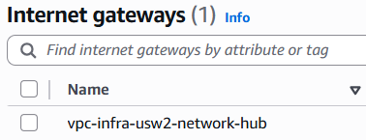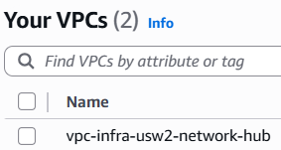
- Observation:
- IIT help is required to gather the information
- Recommendation:
- Trianz will update this section.

Prefix list:
- VPC “vpc-nonprod-usw2-test” Managed Prefix List
Prefix List- pl-1234567890 is added to the Private Route tables – “rt-net-prv-1a” and “rt-net-prv-1b”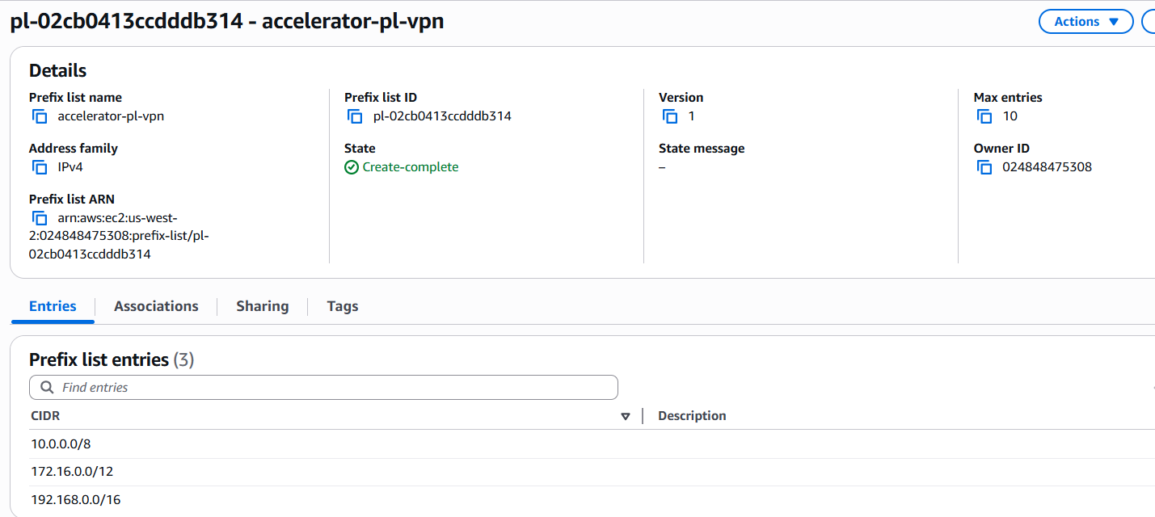
Prefix list entries are 10.x.x.x/8, 172.x.x.x/12 and 192.x.x.x/16.
Observation:
IIT help is required to gather the information
Recommendation:
Trianz will update this section.
10. x.x.x /8 and 192. x.x.x /16 are in the prefix list. If not required for the current setup, consider removing them. For future use, add only when needed as per best practices to keep the list clean and relevant

Transit Gateways
- Transit Gateway Name - network-hub-prod-tgw / tgw-1234567890
- AWS Transit Gateway resource is created in the networking account and share it across the accounts within your AWS Organization
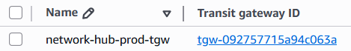
- Observation:
- IIT help is required to gather the information

Transit Gateway Attachment (Network Hub Account)
- Transit Gateway Attachment name - network-hub-prod-tgw
- Transit Gateway Attachment ID - tgw-attach-1234567890
- Network Hub Transit gateway Route Table & attachment details are mentioned in the “Transit Gateway Attachment” section above.
- Observation:
The Transit Gateway Attachment is named tgw-attach-prod-network-hub-vpc for Network hub account, but connects multiple accounts, not just Prod - making the name misleading.
Recommendation:
Trianz will update this section.

- There are 6 Transit Gateway Route Tables created. Each Transit Gateway attachment is associated with the appropriate route table based on the routing and communication requirements

Route Table
Observation:
IIT help is required to gather the information
Recommendation:
Trianz will update this section.

RAM
- AWS Transit Gateway resource in the networking account and share it across the accounts within your AWS Organization using AWS Resource Access Manager (RAM).
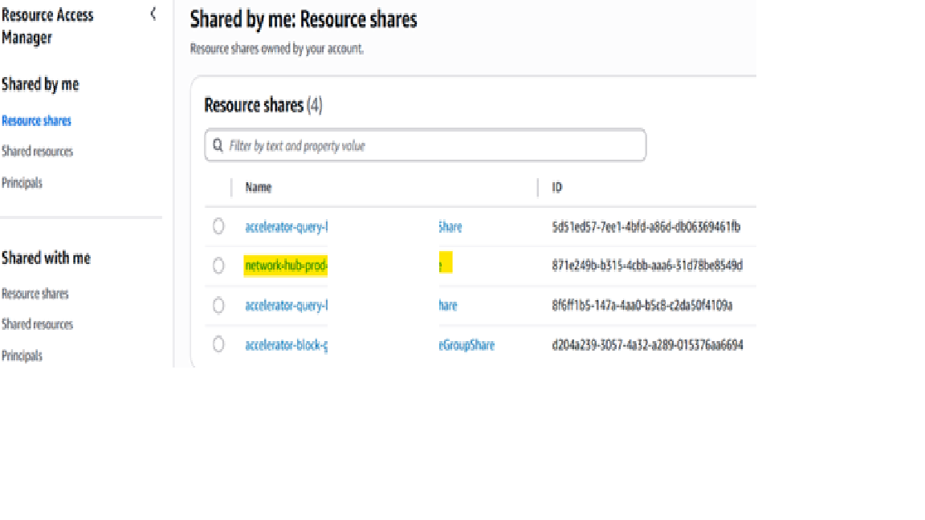
Observation:
IIT help is required to gather the information
Recommendation:
Trianz will update this section.

Reachability Analyzer

IIT help is required to gather the information

Route 53
IIT help is required to gather the information

Load Balancer
IIT help is required to gather the information

AWS Site-to-Site VPN connections
IIT help is required to gather the information

Recommendation
Trianz will update.

NAT Gateway (Network Address Translator)
IIT help is required to gather the information

IPAM (IP Address Manager)
IIT help is required to gather the information

Shared Service Account
- OU: Infrastructure OU,
- Account Name: IIT-infra-shared-services
- Shared Services account is an AWS account created and dedicated to hosting and managing centralized IT services and resources that are shared across multiple other AWS accounts within an AWS Organization.
Contains:
IIT help is required to gather the information

Transit Gateways
- IIT help is required to gather the information
- Observation:
Trianz will update.

Transit Gateway Attachment (Shared Service Account)
- IIT help is required to gather the information

- Observation:
IIT to update.

Load Balancer
- IIT help is required to gather the information

Route Table

Observation:
- IIT updates
Recommendation:
- Trianz updates.

S3 Endpoints
- IIT help is required to gather the information

- Gateway Endpoint Name-
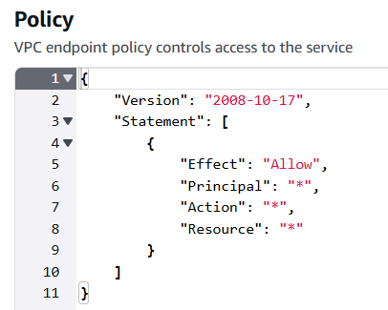
- Observation
- This Policy grants unrestricted access to the VPC endpoint to anyone in the AWS environment who can route traffic to it. This violates AWS security best practices.

- Recommendation
- Replace it with a least-privilege policy that:
- Restricts access to specific AWS principals (like certain roles/accounts),
- Allows only specific actions,
- Applies only to the necessary resources.

Cloud Watch
VPC Flowlogs to Cloudwatch

Production Account
- OU: Production OU
- Account Name: IIT-prod-production
- This account hosts all production workloads and It is isolated from other environments (Dev/Test) to ensure security, stability, and compliance.

Route Table
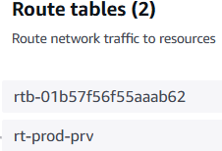
Observation:
- IIT updates.
Recommendation:
- Trianz updates.

Production Account Failover (DR)

S3 Endpoints
- Gateway Endpoint Name-

- Observation
- IIT help is required to gather the information

Production_DR Account
- IIT help is required to gather the information

- OU: Production OU
- Account Name: IIT-prod-dr
- The Prod-DR (Disaster Recovery) account is used to host replicated resources and failover infrastructure from the Prod account

Region
Observation
Recommendation

DR Strategy

Transit Gateway Attachment
Observation

TGW Attachment

Production- DR Failover
Observation

Recommendation (to enable DR failover):

Route Table

Observation:

Recommendation

S3 Endpoints

- Observation
- Recommendation:

Development Account
- OU: Development OU
- Account Name: IIT-nonprod-dev

Route Table
Observation:

Recommendation:

S3 Endpoints

Observation:

Recommendation:

Test Account
- OU: Non_Production OU
- Account Name: IIT-nonprod-test

Route Table
- Observation:

- Recommendation:

S3 Endpoints

Observation:

Recommendation:

Log Archive account
Observation:

Recommendation:

VPC Flow Logs

Audit account

- OU: Security OU
- Account Name: Audit Account

Security Hub
Observation:

Recommendation:

GuardDuty
Observation:

Recommendation:




Contact Information
Name
Email
Phone
reach@trianz.com
The content in this document is copyrighted; any unauthorized use – in part or full – may violate the copyright, trademark, and other laws. This document may not be modified, reproduced or publicly displayed, performed or distributed, or used for any public or commercial purposes. The Trianz name and its products are subject to trademark and copyright protections, regardless of how and where referenced.

